// A.R.L.Santhosh Kumar

int sensor=4, trig=10, echo=10, light=9, buzz=13;

int dist = 0;

// Below function finds the distance of the person from front door

long objectDistance(int a, int b)

{

pinMode(a, OUTPUT); // Clear the trigger

digitalWrite(a, LOW);

delayMicroseconds(2);

digitalWrite(a, HIGH);

delayMicroseconds(10);

digitalWrite(a, LOW);

pinMode(b, INPUT);

return pulseIn(b, HIGH);

}

void setup()

{

Serial.begin(9600);

pinMode(sensor, INPUT);

pinMode(light, OUTPUT);

pinMode(buzz, OUTPUT);

}

void loop()

{

//readUltrasonicDistance(7, 7)

digitalWrite(light, LOW);

dist = 0.01723 \* objectDistance(trig, echo);

Serial.print("Distance is ");

Serial.print(dist);

Serial.println("cm");

if(dist>50 && dist<100)

{

digitalWrite(light, HIGH);

if(digitalRead(sensor))

{

tone(buzz, 50);

delay(100);

noTone(buzz);

}

}

}

OUTPUT: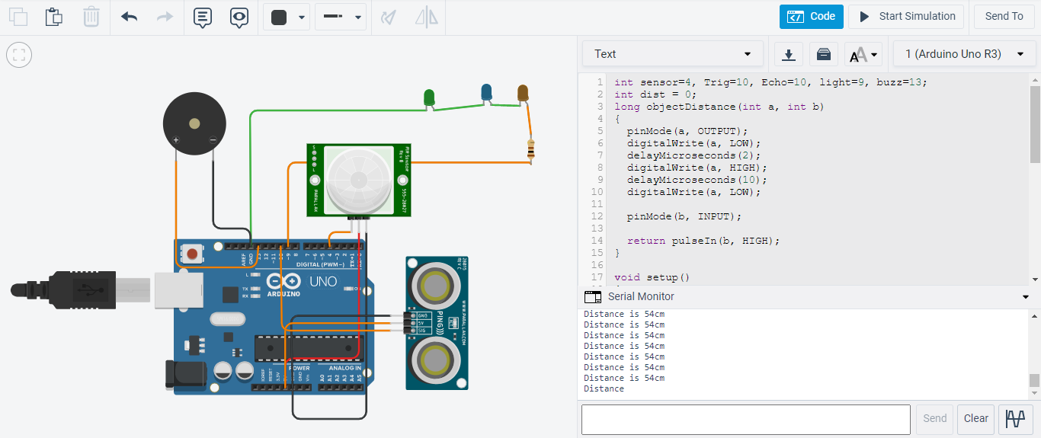CIRCUIT DIAGRAM: